Proper Error Correction Procedure Lesson

- Policy
  - All records and documents are attributable, legible, contemporaneous, original, and accurate.
  - Correcting errors on a record or document are correctly handled, and the date and person who corrected them are documented.
  - Records and documents are legible. When correcting an error, the incorrect information is still readable.
  - All records and documents are reviewed and verified by authorized personnel.

- Procedure
  - Good Documentation Practice
    - All documents and records have an author to easily trace back their source and/or the person conducting monitoring and recording.
    - Records and documents are signed and verified.
    - Records are legible and not vague or ambiguous.
    - Date and versions are indicated in the document and records. All dates are accurate; pre-dating and/or post-dating is not allowed.
    - When correcting an error, ensure that name, date, and signature are placed on the corrected information.
    - Ensure documents and errors are accurate (true, valid, and correct).
    - Reasons for corrected errors are documented.
    - All data are reviewed, checked, and/or validated.
  - Proper Correction of Errors
    - When an error is made, do not use write overs (e.g., Don’t turn a “6” and “9” into an “8”).
    - Instead, properly correct the information by drawing a single line through the error.
    - Make sure that the error is still legible.
    - Correct next to the error with an asterisk and a number on the next available line or space.
    - Explain the error, referring to the asterisk number.
    - Put the Initials of the person in charge with the date written next or on the drawn single line.
  - Correcting errors with a marker, white eraser, or writing over the wrong data is prohibited
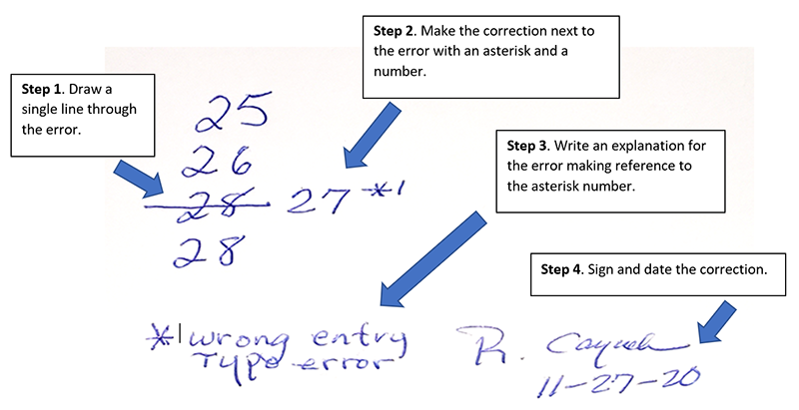
Figure 1. Example of proper correction of error.

Reference: CIQA. 4 Steps to Correct Typo Errors On GMP Data as Per GDP
  - Correcting Errors Electronically
    - When electronic records are retained, the same principle is applied.
    - The electronic record system tracks records of corrections and/or changes made. Original records are viewable, reflecting the current date and time it was entered.
    - If the electronic records are printed, changes are also reflected in the hard copy.
  - Late Entry of Data
    - An addendum provides additional information in conjunction with the previous entry.
      - Indicate the date and time when an addendum is made.
      - Reasons for making an addendum are clearly stated and traceable to the original document and/or data.
    - Clarification note is made to avoid misinterpretation of previously recorded information.
      - Indicate the date and time when a clarification is made.
      - Write “Clarification” and state the reason. Ensure that it is traceable to the original document and/or data.
  - Prohibited Actions
    - Falsification of records is unacceptable and will not be tolerated.
    - Pencils, erasers, erasable ink, and/or whiteouts are not allowed on records.
    - Use ditto marks (“) and leave the required information blank.

- Responsibility
  - All employees
    - Shall adhere to this procedure.
  - Production Manager/Supervisor
    - Ensure that all operators, packers, and all involved in monitoring and recording are trained on proper documentation practices.
    - Ensure that recorded data are valid, accurate, and correct.
  - SQF Practitioner/Quality Control Department
    - Verifies monitoring, inspection, and test records.
    - Controls document changes and modifications.

- Corrective Action
  - Any inefficiencies detected in complying with the Proper Error Correction Procedure shall be addressed immediately by the FSMS management and reviewed.
  - When falsification and/or improper correction was made, conduct an investigation.

- Review – Quality
  - Review Proper Error Correction Procedure annually or when there are changes.
  - Verify records for accuracy, legibility, and correctness.
  - Proper error correction procedure is effectively implemented.
  - All employees are trained with the proper error correction procedure.
  - Any inconsistencies are investigated, and corrective actions are implemented.

- History
Revision No.: | Revision Date: | Description of Change: | Originator / Author Name: | Title / Department:
0 | YYYYMMDD | Original | ENTER AUTHOR NAME | ENTER TITLE / ENTER DEPARTMENT

Requirements:
- The trainee (employee/visitor) has read or received a verbal translation of all or part of the policy, procedure, method, and/or SOP for which they are being trained.
- The trainee has observed a demonstration of the task they are to perform or the procedure for which they are being trained as required.
- The trainee has demonstrated the ability to perform the task with acceptable proficiency and minimal supervision.

TRAINEE (Print Name): | TRAINEE (Signature): | Date: | Department:
Trainer / Supervisor (Print Name): | Trainer (Signature): | Date: | Department:

*Should you need assistance in customizing this document please email csuccess@consultareinc.com

